Case Study – Conference Center

In order to illustrate our approach, we present a case study that was already implemented with LGI and presented in [phdEsteva, phdAguilhar].7.2.3 The example is described as follows.
“A conference takes place in a physical setting, the conference centre, where different activities take place in different locations by people that adopt different roles (speaker, session chair, organization staffer, etc.). During the conference people pursue their interests moving around the physical locations and engaging in different activities. A Personal Representative Agent (PRA) is an agent inhabiting the virtual space that is in charge of advancing some particular interest of a conference attendee by searching information and talking to other software agents.”
The example has been presented in [phdEsteva] has structured this application in six different scenes: Information Gathering Scene, Context Scene, Appointment Proposal Scene, Appointment Coordination Scene, Advertiser Scene, and Delivery Scene. However, more details were given to the scene Appointment Proposal, which makes possible to reproduce, and therefore this scene will be the focus on this paper.
The participants of this scene are two personal representative agents (PRA). The goal of the scene is to agree upon a set of topics for discussing in the appointment. The scene is played as follows:
- one of the PRAs takes the initiative and sends an appointment proposal to the other PRA, with a set of initial topics. This proposal has a time that defines its validity (clock). We will refer to the initiating PRA_{x} and to other PRA_{y}. Wheater the clock expires and PRA_{y} has not answered, the scene moves to s5.
- PRA_{y} evaluates the proposal and can either (i) accept, (ii) decline, or (iii) send a counter proposal to PRA_{x} with a different set of topics. The proposal has also a time that defines its validity.
- in turn, when PRA_{x} receives the counter proposal of PRA_{y} evaluates it and can also either accept, decline, or send a counter proposal to PRA_{y}. This negotiation phase finish when an agreement on topics is reached or one of them decides to withdraw it.

As we have said, PRAs participate in the virtual space representing an attendee and looking for interesting activities and appointments for the user. Thus, when a PRA reaches an agreement for the set of topics for discussing in an appointment with another PRA, the PRA must inform the attendee about it. This is represented in XMLaw through the norm app-notification that can be used in other scenes to prevent agents that have not fulfilled the obligation to interact.

XMLaw solution. Figure 1 shows a graphical representation based on UML statecharts of the interaction protocol of Appointment Proposal scene. The XMLaw specification of this scene is shown in Table 1. There are three types of messages propose, accept and decline (lines 02 to 04). Those messages are used to fire most of the transitions (lines 08,09,10,11,13 and 14). The transition t5 is activated by the clock at line 16. This clock is activated every time transitions t1, t4 or t6 fire; and it is deactivated when there is a firing of transitions t2, t3, t4 or t5. This clock behaves generating a clock-tick 5000 milliseconds after its activation. Line 15 declares the norm app-notification. This norm is given to the RPA that accepts the proposal of topics. This acceptance occurs at transition t2.

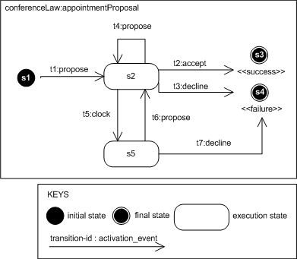
Figure 1 - Interaction Protocol

Table 1 - XMaw Code
01: appointmentProposal{
02: propose{$PRA1,$PRA2,$topics}
03: accept{$PRA1,$PRA2,$topics}
04: decline{$PRA1,$PRA2,$reason}

05: s1{initial}
06: s3{success}
07: s4{failure}

08: t1{s1->s2, propose}
09: t2{s2->s3, accept}
10: t3{s2->s4, decline}
11: t4{s2->s2, propose}
12: t5{s2->s5, clock}
13: t6{s5->s2, propose}
14: t7{s5->s4, decline}

15: app-notification{$PRA1, (t2),()}

16: clock{5000,regular, (t1,t4,t6),(t2,t3,t4,t5)}

17:}

Discussion. When compared to the solution presented in [], the solution presented here has some differences: (i) the set of message definition is reused many times in the protocol, which has lead to a much simpler protocol; (ii) due to the event-model, the clock element is plugged into the law in order to fire transitions. When compared to EI, the transition itself has a timeout element, in other words, the transition provides the functionality of the clock. The separation leads to better separation of concerns, and better reuse once clocks can be composed with other elements; (iii) as the norm is also connected to the event model, its activation is much simpler, one has just to specify which event activates the norm.

